**Procedure How to Configure Thunderbird Mail Client**

1. Click on “Start” menu and type “thunderbird” to open thunderbird application. And Click on “Email” option.

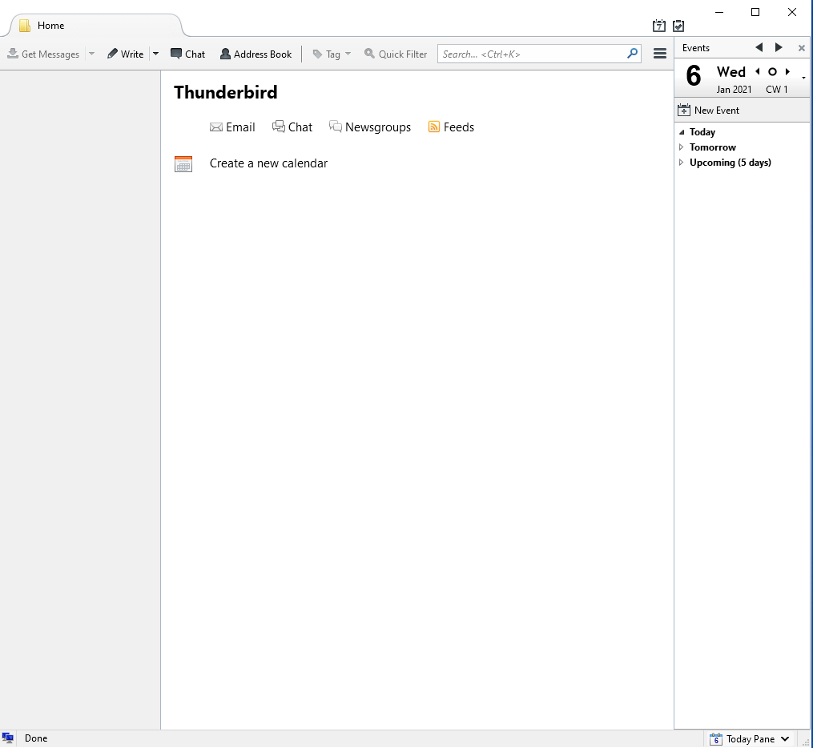

1. Select “Skip this and use my existing email” option.

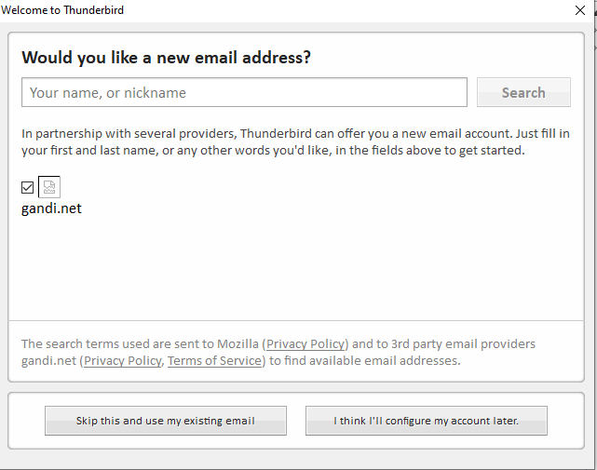

1. Enter email account information and Click on “Continue” option.

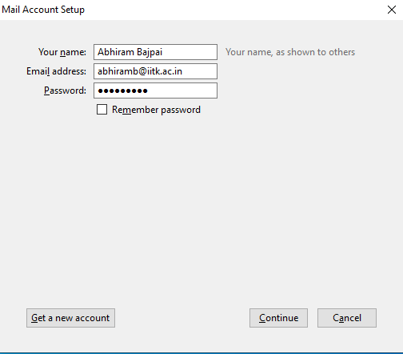

1. Click on “Manual config” option.

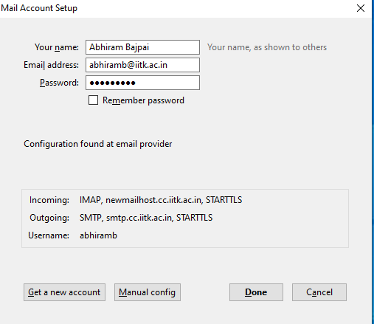

1. Fill the server information as shown below and click on “Re-test” button. And click on “Done” Button.

Incoming Server for External Network**: qasid.iitk.ac.in**

Incoming Server for Internal Network: **newmailhost.cc.iitk.ac.in**

Outgoing Server for External Network: **mmtp.iitk.ac.in**

Outgoing Server for Internal Network: **smtp.cc.iitk.ac.in**

Port no for External Network: **SSL/TLS 993**.

Port no for Internal Network: **SSL/TLS 465**

**NOTE: Use “External Network” settings for Laptops/Mobiles/Tablets and “Internal Network” setting for**

**Desktop.**

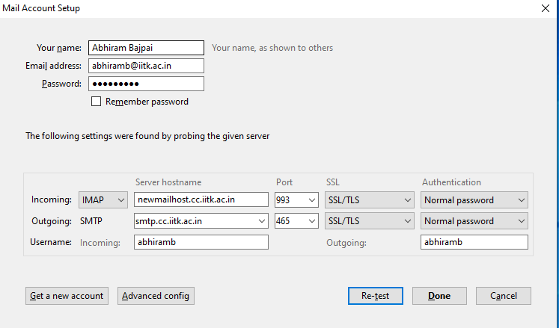

1. Thunderbird mail client successfully Configured.

